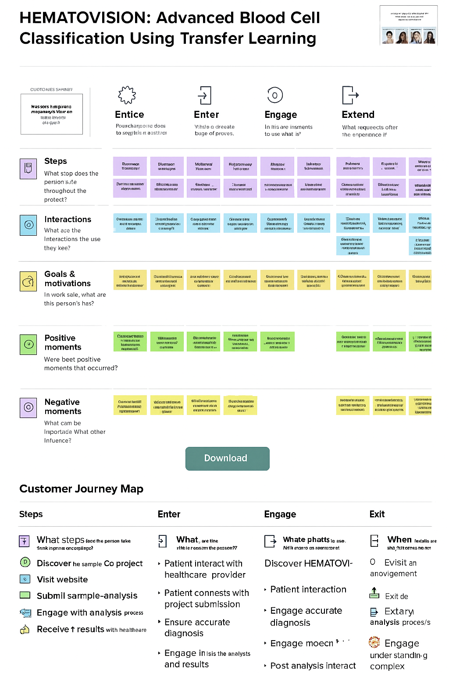

**HEMATOVISION: Advanced Blood Cell Classification Using Transfer Learning**

CUOTONIES SKINDY

Massors hmpireno mopana's Vinir on TESIVOST

oto W.

**Entice**

Pouncharaona does to sorgtelis in austtor

**Enter**

Vhste a dreeate buge of proves.

**Engage**

In Itis are insments to use what is

Extend

What requeects ofter the enperiance it

Steps

What stop does the

persion 'sute

throughout the

protect?

Interactions

What are the

Interactions the use

they kee?

Ruanoco tranninar

Zoran

Dlustruan brians

Matarud

Hojamenny

Phicom го

tantny invimanın

Patinoru

qurula

Wi

S

on'

lemm

BAD niumsomat

perthma от го

2 tunaot mummanri

Allons

Jnmulaud

Centru

Datnoin

atbundes

плодими

Wurnit

lamelame

Dan semin

Owens nam

MLT CO

Chernelan union onamp't

Casted man

mm

amro

Count Danitarim

חז בון

Copnemauf Kauty

wandemaun Do

nuts no

mcbat furori

Ghesuntam Lunatate

NT

Veden.tamning entre

Убава

Carna

Clot ADAT госиской

Goals &

motivations

In work sale, what are

this person's has?

**Positive**

moments

Were beet positive

moments that occurred?

Negative

**moments**

What cam be

Importade What other

Infuence?

antic

Dunimahl Tasca

unub cum

Coll

Da

Shaina BILA

Commata

incurran menutimunaner

CAMEX

eunum

This Thu muas

Okavang m.fondat

aciona

ໄອງເຈົ້າ

menda

**Cannae WmID**

Vashinuta

Oluatient

Bovennab

O

BEL SIGN

nfoliagen Cano

LOVERNAN ACHER

c

UNISIKIA

logannwes ccatos

romastogamer

Воп

antennanter

**Oamen Camo**

Odcmon sritis

Walnu count alen

tentiamsire

этою

6

dontn wor

tralunnuvou

Download

edieren

Песни

**Customer Journey Map**

Steps

(D)

What steps (ecd the person take

Innkinonnas encorpänge?

Discover he sample Co project Visit website Submil sarmple-analysis Engage with analysis process

Receive ↑ results with healtheare

**Enter**

**What are tine**

rttelereasam the peason??

Patient interact with healthcare provider

▸ Patient connests with project submission ▸ Ensure accurate diagnosis

་

Engage in Isis the analysts and results

**Engage**

Whate phattsio Attili marro as reartecorat

**ase.**

Discover HEMATOVI-

⚫ Patient interaction ▸ Engage accurate diagnosis

Engage moecn

▸ Post analysis interact

**Exit**

**When Texalis are**

sha titores na no

O Evisit an anovigement

Exit de

Extary analysis proces/s

Engage under standin-g complex